GSRT Earthworks — Gaining Ground
Referral Pathway & Partnership Overview
A structured destination for people exiting crisis — paid work, housing, and First Nations-led restoration on the Don River corridor
Neil J. Schwab · Framework Architect
GSRT / HALO Group of Companies
neil.schwab@live.ca · +1 (905) 868-6985
Newmarket, Ontario · 2026
The problem this addresses: Ontario spends approximately $120,000 per year managing each high-needs individual cycling through emergency health, justice, shelter, and social triage — with no exit pathway and no asset created. GSRT Earthworks provides the exit pathway: a paid, structured, First Nations-led environmental restoration workforce that converts crisis spending into verifiable community value. This document explains how your organization can refer clients into the pilot and what happens when they arrive.
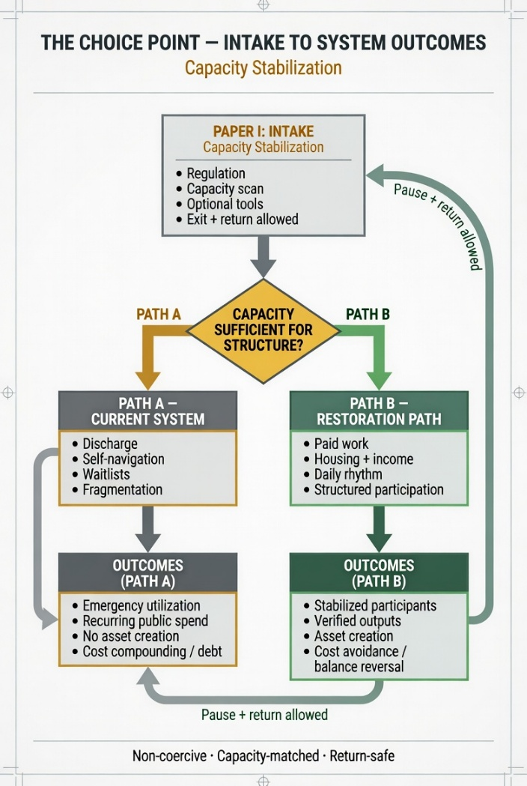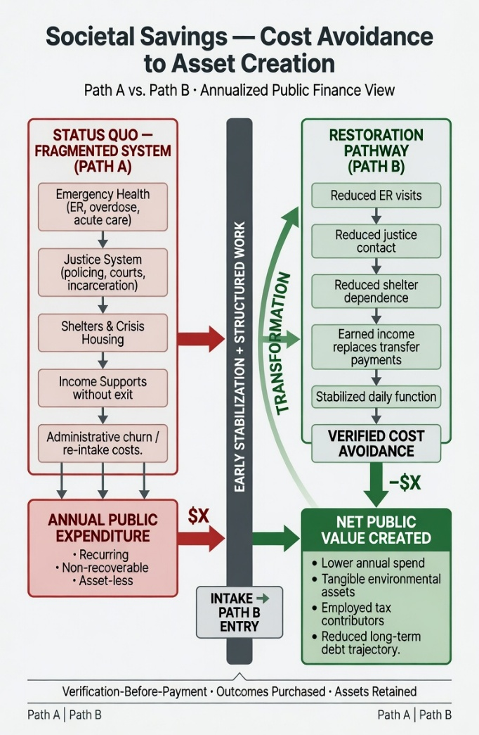
Fig. 1 — The Choice Point: how a referral becomes a Path B placement. Capacity is assessed at intake. If sufficient for structure, the client is directed to the Earthworks pilot rather than the fragmented discharge cycle.

Fig. 2 — The fiscal case: Path A compounds public debt with no asset created. Path B generates verified cost avoidance, environmental assets, employed tax contributors, and a reduced long-term debt trajectory.

The Pilot Structure — 200 Persons, Don River Corridor

The 2+8 Node Architecture
The pilot deploys 200 people across 20 restoration nodes, each covering 2 kilometres of the Don River corridor from Oak Ridges Moraine (Newmarket) to Keating Channel (Toronto Harbour). Each node has a fixed structure:
2
Controllers
First Nations-supplied
Traditional Ecological Knowledge
Node leadership
8
Participants
Referred from CAMH,
city shelters, and
justice system
20
Nodes
× 10 persons each
= 200 person pilot
40km corridor
First Nations Controllers are not supervisors in a conventional sense. They bring Traditional Ecological Knowledge (TEK) as the primary intelligence guiding restoration methodology. They hold the authority of the land, the safety of the crew, and the cultural integrity of the work. Their presence is not a program feature — it is the structural foundation the pilot is built on. First Nations communities supply the Controllers. The pilot does not proceed without them.
What Participants Receive from Day 1
Element | Detail | Why It Matters Clinically
Dignity wage | $22/hour for verified restoration work | Earned income replaces transfer payments — dopamine from mastery, not charity
Housing | Individual sleeping quarters in field camp — not dormitory bunks. Locked door. | Stability as the first recovery condition — no shelter waitlist, no cliff
Daily rhythm | 9:00–15:00 restoration work, communal meals, evening G.A.P.S. practice circle | Serotonin from predictable rhythm — the nervous system knows what comes next
Peer community | Node crew of 8 + Controller — same people, same work, every day | Oxytocin from genuine belonging — not a group therapy room, a working team
Progression pathway | WHITE → BLUE → GREEN → YELLOW → BLACK → GOLD colour-coded competency levels | A future that is visible and reachable from Day 1
Return policy | Prodigal Son Protocol — if a participant leaves and returns, their seat is saved. No re-intake. No penalty. | Removes the shame barrier to returning after a lapse

How Your Organization Refers into the Pilot

CAMH & Clinical Partners
At the point of discharge planning or crisis stabilization, assess capacity for structured participation. If the client can tolerate daily rhythm, outdoor physical work, and communal living — refer to Earthworks onboarding. CAMH's clinical placement students provide the medical float team at the pilot camp (nursing, paramedicine, social work).

City of Toronto & York Region
Shelter staff, bylaw officers, and housing caseworkers can refer individuals at the point of crisis contact rather than shelter placement. Earthworks provides what the shelter system cannot: daily income, structured purpose, and a pathway out. The pilot directly reduces EMS calls, shelter bed demand, and bylaw response in the corridor.

Justice System Partners
Probation officers, diversion program staff, and court services can refer justice-involved individuals as a structured alternative placement. Earthworks is not punitive and does not require justice involvement — but it provides the structure, income, and community that reduce re-offending more reliably than supervision alone.
- Referral partner identifies a candidate and contacts the GSRT pilot intake coordinator
- 90-minute RAFT onboarding: Roof, Addiction medical status, Fundamentals, Target — immediate needs addressed before work assignment
- Capacity assessment: is this person ready for the structure of daily paid work?
- If yes: colour-coded wristband assigned, node placement confirmed, transport arranged
- If not yet: Path A supports continue, door to Path B remains open — no penalty, no re-intake required when ready
What the pilot needs from partner organizations:
① A referral coordinator contact at CAMH, city shelter services, and York Region social services
② Agreement to receive verified outcome data from the pilot (tonnage, hours worked, participant wellbeing indicators) for shared reporting
③ Clinical placement students from partner institutions for the medical float team
④ Support for the First Nations communities supplying Controllers — recognition of their sovereign design authority over restoration methodology

The Fiscal Case in One Line
The status quo costs $24,000,000 per year to manage 200 people in crisis with no exit and no asset. The pilot costs $9,176,544 per year for the same 200 people — and produces clean waterways, restored land, employed taxpayers, and a workforce that repays its seed investment by Year 5 and runs at zero government cost from Year 6 onward.
Every figure is set at or below the conservative floor of its published evidence range — sourced to CIHI, Public Safety Canada, ESDC, Wharton School, Journal of Hydrology, EPA, and UNDRR. A full Citations & Evidence Addendum and Municipal Finance & Risk Mitigation Report are available on request.
Neil J. Schwab — Framework Architect, Global Stewardship & Reconciliation Trust (GSRT) / HALO Group of Companies
neil.schwab@live.ca | +1 (905) 868-6985 | Newmarket, Ontario, Canada
Forgive Yesterday · Heal Today · Flourish Tomorrow · Together · PBTGThis document is intended to invite conversation and referral coordination — not to constitute a binding commitment from any party. Full supporting documentation available upon request.

